My name is James Garrigan. [www.jamesgarrigan.nyc](http://www.jamesgarrigan.nyc)

**Skills:** IT Infrastructure | PowerShell Automation | Windows Server | Active Directory | Technical Book Reviewer

**NATIONAL SECURITY ELIGIBILITY DETERMINATION:** Federal Public Trust (SF-85P) [Interim (See footnote)*]

**Portfolio:** [Work samples](https://www.youtube.com/playlist?list=PLgkRipPFmxPPvjxYbTR-iDrGWWwJMJg0y) (details altered)

**Seeking:** Full-time or long-term W2 contract roles with benefits in NYC. I do not have a car.

**Objective:** I am looking for a role that leverages my technical skills to support colleagues and the organization. I am eager to learn, and I thrive in supportive environments.

**Values:** I value honesty and believe a good reputation is priceless. I have been sought out by past employers, including Lloyds Bank, for legal matters. In addition, the NYC Council’s technology committee, the New York Post, and Bloomberg’s newsroom reach out regarding public interest matters. I know my strengths and limitations and I am not afraid to seek assistance.

**Website:** [www.jamesgarrigan.nyc](http://www.jamesgarrigan.nyc)

**References:**

* C-level executive at [ ] Bank: Received positive feedback from Tech Systems.
* VP of Application Support at [ ] Bank: "James is a hard worker, knowledgeable on various platforms."
* Director at [ ]: "James is very knowledgeable about IT systems and would be an asset to any company."
* IT Integration vendor: "Thank you for the amazing turnaround and professionalism."

**Experience:**

* Managed adversity while configuring computer equipment for Goldman Sachs/Marshall Wace.
* Multi-talented: Wrote a short story that led to a filmed/taped Q&A session at the Producers Club in Times Square.
* At the NYC DOE, I created PowerShell scripts to automate tasks. The primary task was creating and maintaining a script that automated the configuration for 3400+ Hyper-V servers.
* Provided sound advice for previous employers and at the NYC DOE I leveraged PowerPoint to present operational concerns.

**Cover Letter and Resumes:** <https://www.garrigan.nyc/cover-letter-and-resumes/>

**Recommendations/Testimonials:** <https://www.garrigan.nyc/testimonials/>

* On October 29th, 2024, I learned the government job was put on hold on or before October 10th, 2024. It seems you’re cleared, but unfortunately, the position in New York is currently on hold from the client’s side. They issue an interim clearance first, and then you receive the final clearance after the interview. You can start working with the interim clearance.

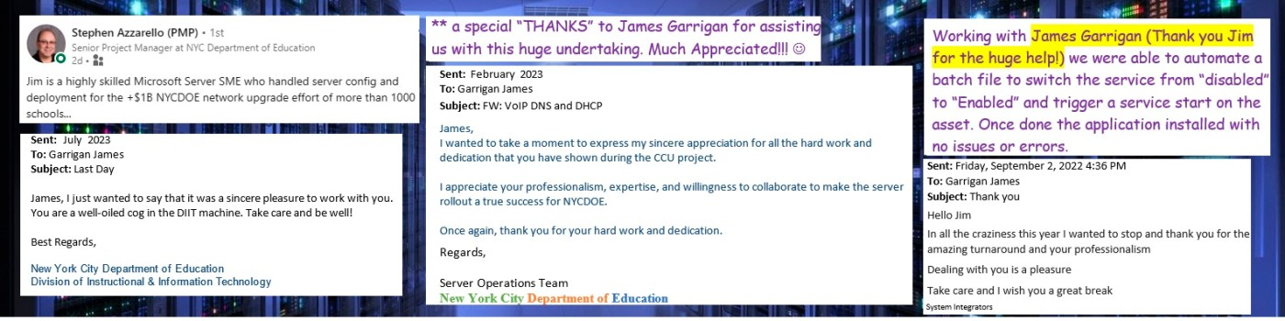

Regards,

Jim Garrigan

garriganjobsearch@outlook.com

[www.linkedin.com/in/jimgarrigan](http://www.linkedin.com/in/jimgarrigan)

**Additional details and resumes are at** [**https://www.garrigan.info/**](https://www.garrigan.info/)

**Other**

**Videos of sample work products:** <https://www.youtube.com/playlist?list=PLgkRipPFmxPPvjxYbTR-iDrGWWwJMJg0y>

**Interview Requirements:**

* Please share the full job description via email at least one business day before the meeting.
* Meeting requests require two business days of lead time and confirmation within two hours.
* An unconfirmed time slot is an available time slot. The local time zone is America/New York.
* Video calls require a dial-in telephone number for audio, and all participants must be visible.
* Permission to record and/or transcribe audio/video calls is neither granted nor assigned to any entity.

**Preferred Contact Method: Email** [garriganjobsearch@outlook.com](mailto:garriganjobsearch@outlook.com)

**Personally owned equipment policy:**

I do not use personally owned equipment for job-related electronic communications. A few examples of prohibited use are apps, chat, email, text, and video. In other words, job-related data of any type is neither saved on nor passes through personally owned equipment.

I may use personally owned equipment for job-related work solely for voice calls via a cellular/landline phone and remote computer sessions via a virtual machine designated only for the job. Only screen images, keystrokes, and mouse actions flow between the remotely connected systems.